**Crunchwrap Supreme Recipe**

1. **Dish:** Crunchwrap Supreme

2. **Origin:** Taco Bell (Fake Mexican)

3. **Source:** Taco Bell Website

4. **Category:** Comfort Dish

5. 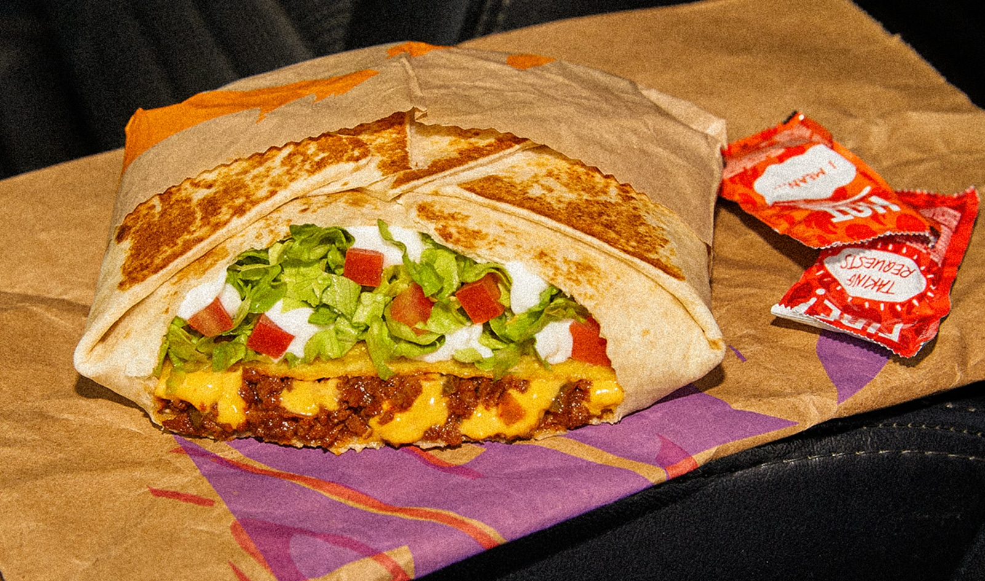

6. Crunchwrap_Supreme.png

7. Despite the noticeable price increase attributed to inflation, I'm an avid Taco Bell fan. There's an undeniable satisfaction in indulging in a Crunchwrap Supreme whenever hunger strikes. Fusing a traditional Mexican taco with a generously sized flattened burrito creates a symphony of flavors that resonates perfectly with my taste buds. The mere thought of it sets my stomach on a journey of anticipation, as each bite combines the comforting essence of familiar ingredients in a novel and exciting way. Yo quiero Taco Bell.

8. **Recipe Ingredients:**

**a.** Tortilla

**b.** Ground Beef

**c.** Circular taco shell

**d.** Cheese

**e.** Lettuce

**f.** Sour Cream

**g.** Melted Cheese

**h.** Diced Tomatoes

**i.** Taco Bell seasoning

**j.** Cheese sauce

9. **Recipe Steps:**

**a.** Make the ground beef with taco seasoning, season it well with spices and Taco Bell spices from Target

**b.** Lay the tortilla on the grill and put cheese sauce on top of it, smooth it out in a circular motion, and be generous with the amount

**c.** Next, put the circular crunch taco shell on top of it while adding a generous amount of sour cream on it, don't be shy!

**d.** Next add your seasoned to ground beef onto the tortilla

**e.** Finally, add your diced tomatoes, lettuce, and cheese.

**f.** Wrap your Crunchwrap pentagon style and then grill it on a hot pan for about 4 minutes on medium heat, both sides

**g.** Take it off the pan and then cut it in half and you have your Crunchwrap supreme

9. Taco_Bell_Beef.png

10. Cook the beef on high heat while adding Taco Bell seasoning and let it simmer for 10 minutes on low

11. Taco_Bell_Beef_Cheese.png

12. Example of the assembled Crunchwrap supreme with toppings on the tortilla

13. Crunchwrap_Supreme.png

14. Finished product of a Crunchwrap

15. **Audrey Eng**